Writing Made Easy - 14 Tips to Better Writing

-ier

NOTE: Many of the mini lessons below are written in 2nd person—that is, with the use of “you.” In this document, I do that to create the intimate atmosphere of a personal discussion. However, in most cases, good writers avoid 2nd person and 1st person (“I”) and write in the objective voice of 3rd person—using the third person pronouns he, she, one, or they. The use of 2nd person should be restricted to speeches and conversations. Those writers who purge their writing of the use of 2nd and 1st person sentences, and stick to the objective voice, generally find more success. (There will be more on this in Skill #12)

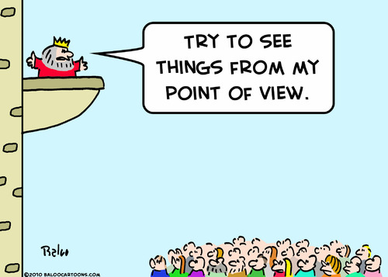
1. Develop a Point of View, not an opinion

Read and listen critically - watch and listen for facts, ask questions, think of reasons why something is good or bad, right or wrong, based on solid (concrete) reasons - not just your own feelings.
Everyone has opinions (“this class is great, that movie is boring, I hate my brother; Mr. Walsh is cool.”) but opinions are meaningless without solid reasons--no one really cares how you feel about a given situation if you cannot explain why. However, once you can defend or prove an opinion with hard evidence, then it becomes a point of view, and people will listen to you.
Example: Mr. Abhanian’s class is exciting: students read stories they have never read before and talk about poems, novels and even song lyrics so they really come alive.
Example: The movie that just opened has a predictable plot and flat, uninteresting characters, and ends with a chase scene that is identical to every other action movie released this summer. Above all, it fails to surprise the audience, and surprise is an important part of any form of entertainment.

2. Play the “Believing Game” or “You Aren’t Smarter Than Emerson”

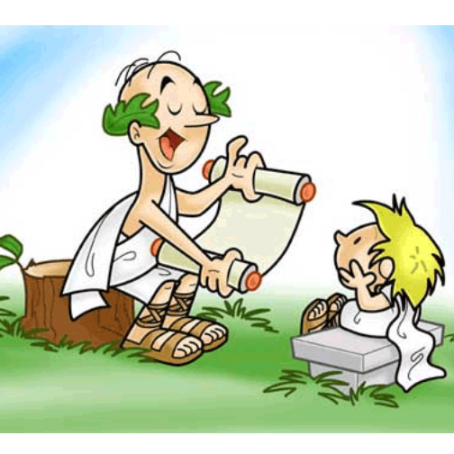
Many essay prompts, especially on high-stakes exams, begin with a quote from a published author, a well-known statesman, respected authority or great thinker. Often the writing task involves explaining the quote and taking a position on it (see Writing Tip number one above). Young writers often adopt the foolish strategy of launching into an essay that contradicts the quote and explains why this writer knows so much more about the topic than the person being quoted. Avoid that pitfall. Instead, play the believing game—discuss the merits of the ideas from the quote and explain how it can represent a kind of universal truth. If, at that point, you still want to take issue with the ideas, your contrasting position will be based on understanding rather than on the juvenile desire to show someone up—someone who is already respected by the world and perhaps by several generations of educated adults.

3. Write as you Read

If you wait until you finish reading something and then start making notes or writing an essay, it is too late. How can you remember what happened on page 34 when the book ended on page 461?
Make notes chapter by chapter. Write “Chapter 1” (or whatever the first section is called), and then look for something important to write down during that section. An easy format is the dialectical journal, which is just a fancy way of saying “paper with a line down the middle,” like the picture below:

A Tale of Two Cities
Chapter 1

“It was the best
of times; it was
the worst of
times…” (3).
If you copy passages from the text on the left side of the paper, you can make notes about the passages on the right side, and then it’s easier to remember why you copied down that passage in the first place. It makes it easier to review the book the night before the test, or when you are writing your essay, at midnight...with the TV on...while listening to your iPod.

This is a famous line and it will probably be on the test. It implies that times were very hard, but there were some important things happening.

4. Action Verbs
Use action verbs instead of linking verbs whenever possible. Linking verbs simply link the subject to an adjective or noun in the second half of the sentence and therefore do not add any action or life to the sentence. A paper filled with linking verbs dies on the page and bores the reader. Forms of the verb, “to be” are linking verbs, as well as verbs like seem, appear, feel, remain and others.

Example 1 (weak):
“In the opening chapters of The Scarlet Letter, Hester Prynne is the main character, but later Roger Chillingworth is also important.”
Example 2 (improved):
“The opening chapters of The Scarlet Letter focus on the unhappy situation of Hester Prynne, but later in the story, Roger Chillingworth emerges as a major character in the novel.”

Notice how the two dull linking verbs (is, is) have been replaced with focus and emerges—two action verbs which paint a more vivid picture of the thought process of the writer.

You may also notice that replacing those dull verbs requires more than just pulling out a weak verb and putting in the new, improved verb in its place. You will frequently need to rebuild the sentence slightly to accommodate the action verb, but it will always be worth the trouble.

Other forms of the “to be” verb: am, is are, was, were, been, be

HINT: Once you have finished your first draft of any writing assignment, go through the paper and circle all of the forms of “to be.” Then, try to replace them with action verbs - you will find lots of them in a Thesaurus.

5. Action Verbs Part II
Avoid forms of the verbs “to get,” “to do” and “to have”
and replace them with action verbs whenever possible.

Same drill as with linking verbs - these three verbs are kind of general-purpose words that we tend to use as “place holders” while we do our thinking. The trouble is, most people forget (or simply don’t know) to replace them with more vivid, descriptive verbs later.

HINT: Again, turn to your friend, the Thesaurus, for more powerful verbs.

Example (weak):
I wanted to do something really good for my project, because I get a good feeling when I do good work.
Example (improved):
I wanted to create something original for my project because I experience a feeling of accomplishment whenever I produce high quality work.
Notice that when you rewrite sentences with action verbs, it also leads to more eloquent constructions of sentences - the word encounters leads smoothly to the descriptive phrase “many obstacles” instead of the dull phrase, “a lot of trouble.”

Example (weak):
Huck Finn has a lot of trouble in his life.
Example (improved):
Huck Finn encounters many obstacles in his life

6. Writing Trap #1 - “In my opinion...”


Avoid saying: “I think,” In my opinion, “The way I see it,” “I believe,” and of course, the combo meal of “What I really believe in my own personal opinion, I think, is...” Instead, go directly to the subject.

Example (weak): In my own personal opinion I believe that the energy crisis in California could be all about wasting electricity and no one trying to be careful.

Example (stronger): The energy crisis in California was brought about by people wasting electricity when they should have been conserving it.

Notice that the second statement cuts to the heart of the matter, establishes a point of view - not an opinion - and sets up a clear thesis to be defended. Of course, the statement requires some kind of proof (concrete evidence) but that will make up the rest of the essay.

Notice also that the weaker verb “be” in the first example was replaced with “brought about” and then by “conserving,” both of which show action rather than condition.

7. Active Voice, Good; Passive Voice, Bad!

Good writers write in Active Voice.
Passive Voice is used by weak writers.

The two sentences above illustrate an important skill—the use of Active Voice.
Here’s the deal: English sentences are generally written with a simple formula: Subject, verb, object.

Example: Eli Whitney invented the Cotton Gin.
Eli Whitney is the subject, invented is the verb, Cotton Gin is the object.

We can also write the sentence in Passive Voice:
Example: The Cotton Gin was invented by Eli Whitney.
You can see that the object of the action (the Cotton Gin) is now in the beginning of the sentence, acting as the subject. Also, the verb now has an auxiliary added to it (was) and the person who did the action is put last. OK, so this is a practical tool that writers sometimes use just to change up the look and sound of a text. But many writers fall into the habit of putting many sentences in passive voice, and it gives the text a dull, lifeless feeling. Another problem with passive voice is that we sometimes drop the actor altogether.
Example: The decision was made to eliminate all paid holidays for employees who have been at the company less than five years.
Well, now—who made this decision? Can you tell by the sentence? No. And that is the point—many politicians (and others who don’t want to answer for their deeds) use the passive voice to make statements that can’t be verified by anyone, or which are intended to hide the truth. Because of this, passive voice comes off as deceptive, or at best, uninformed. So, when you finish a piece of writing, look through your writing and circle all of the passive voice constructions. Then, if possible, change them to active voice.
Example:
Passive: Appropriate staff committee structures are still being developed for next year.
Rewrite in Active: The teachers and administrators together are developing committee structures for next year.

See how we now know who is developing the committees? It also sounds less stiff and government-form like. This one skill will improve your writing more than you can imagine. Your writing instantly becomes livelier and more readable.

8. The Last Paragraph--or is it the First?
When you write an essay, go ahead and write a complete first draft. Write until you think you have finished. Then, look at your last paragraph. It usually contains a strong enough idea for a really effective essay.
Throw away everything but that last paragraph and start again!
I know what you’re thinking: “If I get that far into an essay, no way I’m going to throw out most of my hard work and start all over!” Trust me, it will improve your writing on almost every assignment.
Why does it work? Because most students are so careful about their first few paragraphs they forget to actually think. They try to rephrase the assignment in the opening sentence to make it sound like an introduction. Then they repeat themselves three or four times trying to stretch and fill - when what they are really doing is warming up for the real task of writing.
By contrast, when you, as a writer, get near the end of an essay, you usually are familiar enough with the material, and more importantly, familiar enough with your own ideas, that you are able to relax and come up with a nice, strong statement about the subject. As painful as it may be, that is when your real writing should begin.

When you write an essay, go ahead and write a complete first draft. Write until you think you have finished. Then, look at your last paragraph. It usually contains a strong enough idea for a really effective essay.
Throw away everything but that last paragraph
and start again!
I know what you’re thinking: “If I get that far into an essay, no way I’m going to throw out most of my hard work and start all over!” Trust me, it will improve your writing on almost every assignment.
Why does it work? Because most students are so careful about their first few paragraphs they forget to actually think. They try to rephrase the assignment in the opening sentence to make it sound like an introduction. Then they repeat themselves three or four times trying to stretch and fill - when what they are really doing is warming up for the real task of writing.
By contrast, when you, as a writer, get near the end of an essay, you usually are familiar enough with the material, and more importantly, familiar enough with your own ideas, that you are able to relax and come up with a nice, strong statement about the subject. As painful as it may be, that is when your real writing should begin.

Caution: Some students suffer from the dreaded “I better-make-a-big-important-statement-about-life-the-universe-and-all-of-creation” syndrome. Those students usually turn that nonsense statement into the final paragraph of their first draft (which they hope will also be their last draft). If you fall into that group, then you better choose your second-to-last paragraph, because that’s probably where you stopped thinking and started slinging.

9. Writing Trap #2 - Repeating the question (or, “fill-in-the-blank” writing)

Watch out for the trap of repeating a question in the form of a statement and then attempting to “fill in the blank.” This practice will paint you into a corner with almost no way out, and it usually forces you to use the dreaded “to be” verb. This kind of trap usually occurs in a writing situation where you have been given several questions with the assignment of responding in short or medium answers. Of course, it can also happen in a long essay assignment as well.

Example:
Question: What autobiographical facts does the author of the poem reveal in lines 1-9?

Answer (weak):
“The autobiographical facts the author of the poem reveals in lines 1-9 are _____________”

(This is a dead end - whatever you write cannot possible save this sentence; you have only one option and that is to “fill in the blank” with a list of nouns or clumsy phrases)

Answer (stronger):
“In lines 1-9 of “Tintern Abbey,” William Wordsworth reveals that he spent most of his younger days alone, with “thoughts of deep seclusion.”

Notice the stronger answer still addresses the question, but does not attempt to fill in the blank. The second answer also includes some other sure-fire winners in the eyes of most teachers: it gives the poem’s title and author; it also inserts a quote directly from the poem to prove the answer is a good one, and it uses a strong action verb (reveals) and no linking verbs!
10. Writing Trap #3 - Empty, Meaningless Phrases and Contradictions

This is a common disease among high school writers who are trying to find a “way in” to an essay. You know you have to write an introduction - I mean the format for all essays calls for Introduction, Body Paragraphs, Conclusion - and you have no idea how to get started.
Solution? Say something meaningless! Like, “In the world....” or “In life....” or “In society,” or “All poets write important ideas...”
When you go back and read your first draft (and you MUST read that first draft with the idea of improving it) look for these empty, meaningless phrases you threw in just to get your pen started on the paper, or your curser started on the screen, and get rid of them!
The best approach to any essay is to simply give your main idea and move on to the body paragraphs. If you think one main statement is too little for an introduction, think about your topic and say something meaningful about it. If you find yourself making one of those big generalizations, stop and simplify. Believe me, no teacher wants to read a lot of extra words that you threw in just to make it look like you did more work.
Another common problem is self-contradiction. This usually takes a form like “Walt Whitman and Emily Dickinson are the same, but very different.” Nothing weakens your writing faster than a statement that cancels itself out. If they are the same, they can’t be different. Choose one or the other and make your case. Just because the assignment says “compare and contrast” doesn’t mean you have to do both in the same sentence.
A closely-related disease is the one that drives people to say something that is true for everyone in the world—“We all have dreams and aspirations…”
If something is true for everyone, then DON”T SAY IT!

11. Avoid Cliché’s Like the Plague
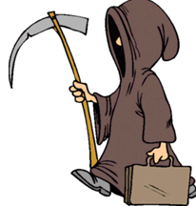
It is very hard to get through a conversation, much less an entire paper, without using some “tried and true” (in other words, worn out) phrases. Clichés help us complete a thought without thinking too hard to find an original way to express an idea. They exist because people hear a nice turn of phrase and repeat it to achieve the same powerful effect they felt when they first heard it. Unfortunately, once that process has been repeated thousands of times, the original figure of speech no longer has any power. In fact, the exhausted combination detracts from meaning instead of enhancing it.
Below are a few clichés with some suggested alternatives. No one can create a comprehensive list because we humans seem to thrive on clichés, but whenever you hear yourself repeating some oft used figure of speech, stop and look for a fresh alternative.
We agreed to disagree We got tired of arguing
He always has my back He is a loyal friend
(Think carefully about this one—many people use this expression because they don’t know what to say about someone, and they think they should say something positive. Instead, think about the person and say something specific: “He understands my odd sense of humor.” “She lets me complain without interrupting.” “She makes me laugh at myself when I’m being foolish.”)
Each and every (or any and all) Choose one, or find another way.
It was a foregone conclusion that No one was surprised that.
The day was a real roller coaster (or had ups and downs) Do you really need to say this?
He was pushing the envelope He wasn’t afraid to try something new.
24/7 Say “always” or anything but this!
12. The Literary Present Tense
When writing essays or short answers about literature—poetry, short stories, novels, plays, songs—write in the present tense instead of the past tense.
Example (weak): After he faked his death at Pa’s cabin, Huckleberry Finn paddled to his favorite hideaway: an island in the middle of the Mississippi river.
Example (stronger): After he fakes his death at Pa’s cabin, Huckleberry Finn paddles to his favorite hideaway: an island in the middle of the Mississippi River.
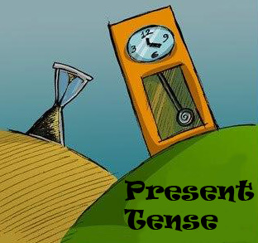
Why should you do this? There is no simple answer. Some teachers might even suggest that it is not necessary, or even that it is artificial and old-fashioned.
The best reason is this: Literature is still alive as long as people are reading it and experiencing it, and therefore the action is ongoing and should be discussed in the present tense.
Another reason is that is sounds more like the analysis of the literature has not been completed, that the discussion continues so why not write in the present tense.
A third reason, though admittedly not the strongest, is simply that this is the style that all serious writers use when discussing literature. You could say that you are going to ignore that tradition and write it the way you want to, but why swim upstream? Learn this system and use it when discussing literature.
Note: When you are writing a narrative (an original short story, say), go ahead and write in the past tense. This is the accepted tense for story telling—the “once upon a time” tradition.


13. The Analytical Voice
Almost all writing in English class is analytical, and the best style to adopt is the objective, analytical voice. Yes, you will occasionally write a short story or poem, and sometimes you will write an impassioned persuasive piece, but mostly, you will be called upon to analyze a piece of writing from a detached, objective point of view, offering only analysis. Think of yourself as a CSI investigator, looking for clues at the scene of the crime and examining all of the evidence to come up with an unbiased and insightful interpretation of the facts with a reasoned and logical theory of what is going on. The CSI suggests a scenario for the crime to explain all of the evidence. As a writer of English papers, you must present a logical analysis of a piece of writing that makes sense given the evidence found in the text.
Writing in the Analytical Voice means you will write in the third person; you will write without emotion or opinion; never use the phrase, “What the author is trying to say is…” because you have no idea what he or she was “trying” to do. Simply say, “The writer argues that …” or “The author suggests that…” and then present your clues from the crime scene (quotes or summaries of the text) to support your theory.

14. Speech-Making for Dummies

Write an outline, mind map or list of good ideas about a subject—and be sure to include those concrete details. (Remember details?—the stuff that makes a point of view worth listening to).

Write each big idea on a 4x6 card in large letters so you can read it easily. (Don’t write whole sentences in detail, just a few key words to remind you of the idea)

Organize your cards (in other words, your ideas) in the order that sounds the best.

Go through the cards in front of the mirror, hold the cards up above waist-level and read the words, filling in the parts of your ideas you left out when you wrote the short versions.

Give your speech the same way you practiced, but try to make eye contact with people in the room between phrases. When you get to a part your really know well, lower your cards and just talk to the audience.

Most importantly: when you are done with your ideas...sit down! Don’t just keep talking because no one stops you.

